 Pangani Basin Water Board 
Hydrological Bulletin November 2025
2025

RAINFALL TRENDS
Rainfall data shows low daily rainfall amounts and few rainy days consistent with the tail end of the short rains in this month. General weather forecast in this period do not indicate significant rain events compared to the previous year in November. The average rainfall of the Basin in this period is 49.6mm below than the long-term average (2004-2024 LTA) of 70.1mm recorded from representative stations.
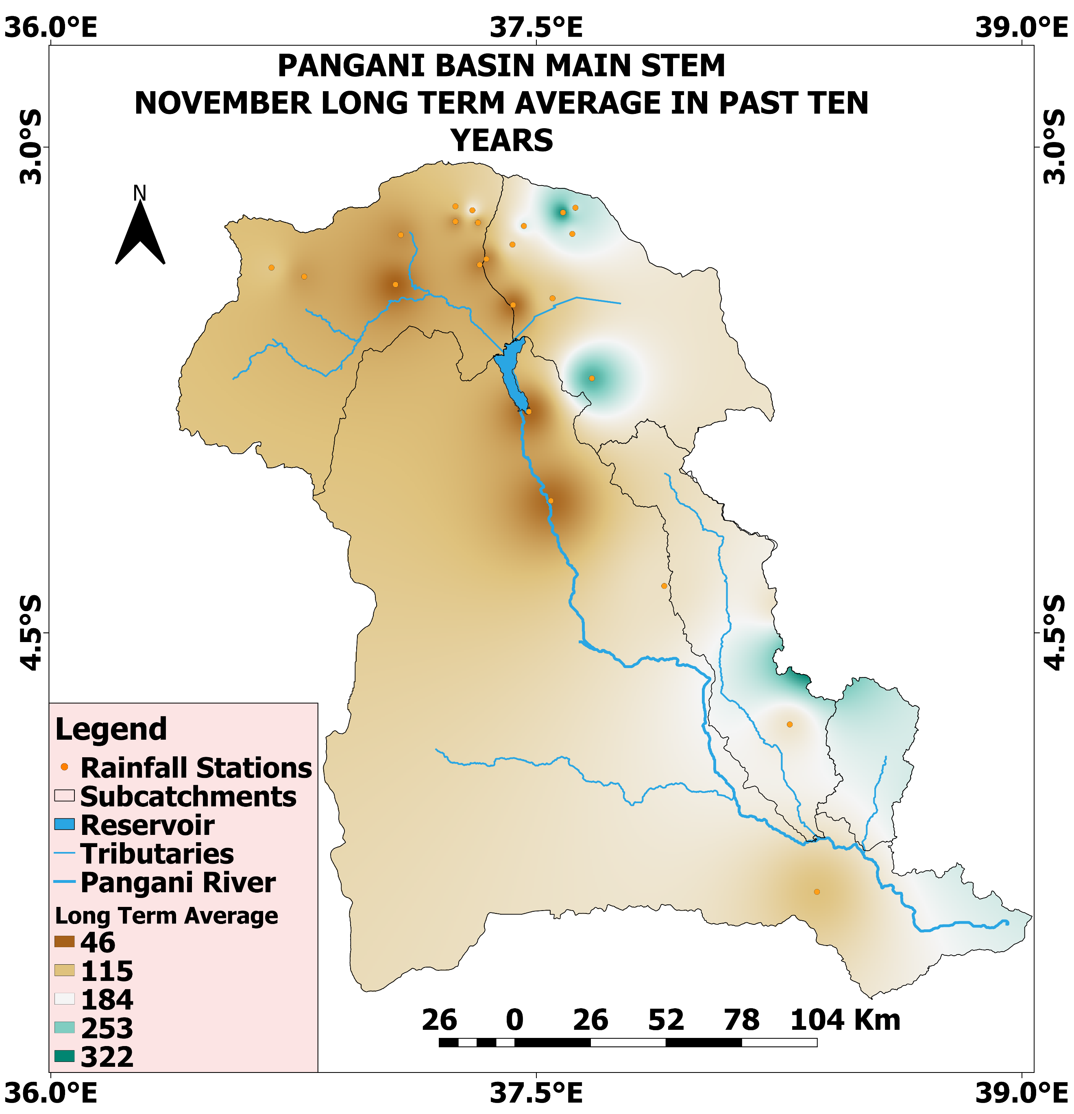
Representative Rainfall stations

RIVER FLOWS
The average flow of Pangani River at Nyumba ya Mungu is very stable in this period (November 2025) compared to 2024 as indicated in the figure below. The Pangani river flows trends have been better despite being influenced by upstream regulator Nyumba ya Mungu Dam.

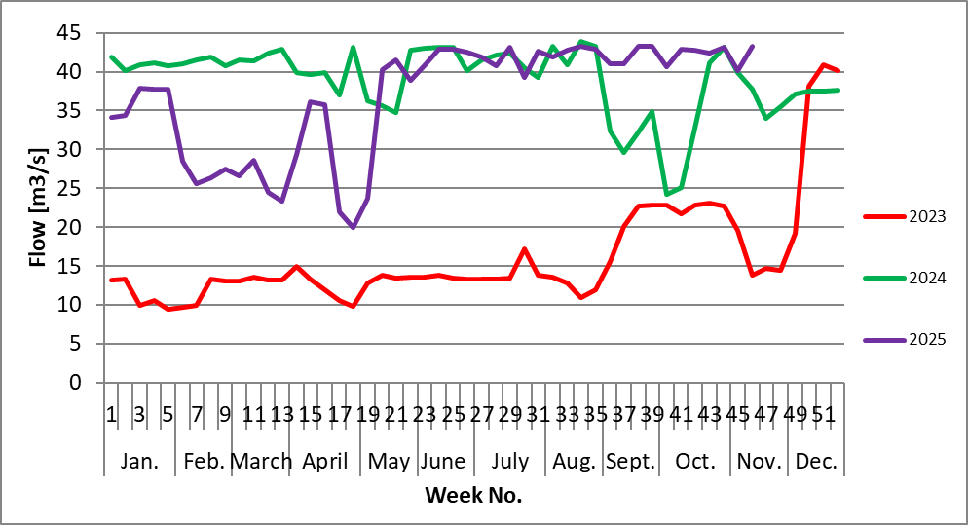
Unlike to the Ruvu, Flows of the Kikuletwa experienced alternating recession and and short peaks during the first twenty day indicating that the catchment flow and runoff was very responsive to the rainfall and probably due to saturation satisfaction in the month of October. In the last ten days the flow showed a reasonable increase in flow and as a result recorded the monthly maximum of the decade equaling 46.6 cumecs.

IMPORTANT DAM DATA:
- HWL – Highest Water Level
- LWL – Lowest Water Level
- WL – Water Level
- Dead Storage 693.61 Million Cubic Meters (MCM) = Below 679.15 masl
- Live Storage 606.39 Million Cubic Meters (MCM) = 679.15-688.91 masl
- Catchment Area of Nyumba ya Mungu Dam = 2,962 m²

WATER LEVEL IN DAMS
Nyumba ya Mungu
Water level in the Nyumba ya Mungu dam is affected by rainfall and runoff situation in upstream catchments (Kikuletwa and Ruvu). The average net inflow into Nyumba ya Mungu dam (calculated) in year 2025 is 43.58 m³/s compared to Long term (1993-2019) mean annual net inflow is 21.63 m³/s. Water level in the week no. 44 (November 2025) is 685.44 metre above sea level. This level is above minimum water level for hydropower generation (683.35 masl) by 2.09m (see figure 3 below).

Generally, the trend of water levels is due to the high quantity of the long rains (Masika) started mid of March and lower quantity of short rains period (October to December) as confirmed by Tanzania Meteorological Authority (TMA).

CONCLUSION
Generally, in the reporting period (November 2025), the water resources outlook in this basin have proven to be health. As we are heading to rainfall season, Basin water status is expected to be higher than their monthly averages.

